Staffing
- Purpose: Staffing is prepared to ensure sufficient permanent funds are available in each COA to cover all permanent academic and staff employees’ salaries for the current fiscal year. Final Staffing reports are shared with the Office of the President (Quarterly). Every attempt should be made to present staffing as accurately as possible and must be in balance with the budget in Oracle.
- Due Date: The Staffing Detail and Staffing Summary Report in Oracle requires regular review to ensure Staffing is in balance (e.g., that the staff salaries budget in the permanent budget system is equal to the cost of the annual salaries of career employees currently in the payroll system, plus open provisions).
- The campus requires that staffing be in balance at these dates: September 30th, December 20th, March 31st, and May 31st (in preparation for fiscal closing) and FP&A will communicate to the campus exact deadlines for final submission in June. If the ORG’s staffing does not balance on the first working day following these due dates, Financial Planning and Analysis will force a backend balance of staffing and the CFAO will be notified. It is the CFAO’s responsibility to ensure the appropriate corrections are executed as the force balance will occur outside of the Oracle Budget process.
- General Procedure: The information on the Staffing Detail Report is generated from BDP (Budget Distribution Page) employee payroll information contained within UCPath, the permanent budget and SmartView 4.50 FTE Data Entry workbook. Therefore, changes to the staffing data are accomplished through the balancing of three separate data elements:
- Budget Distribution Page (BDP)
- Oracle Budget transfers via Smartview
- SmartView 4.50 FTE Data Entry form
- Budget Categories: Staffing is prepared for five academic budget categories (BC10, 11, 12, 13 and 14) and two staff budget categories (BC25 and 26).
  - Note: BC28 should never be permanently budgeted. Its intended use is for career employees paid from non-permanent sources.
- Core Funds: funding is provided centrally for permanent BDP positions on Core Funds: 19900, 19912, 19924, 19942 and 67000. (20000 funds will be provided as an offset from SSFAC Central pool).

Academic and Staff budget categories with the accounts and the UCPath Action Codes are listed on appendix A.

- FTE Precision: All Full-Time Equivalents (FTE) must be displayed with two decimal places according to UCOP standards.
- Provision (Vacant Position) Management: Group provisions need to be designated with "Provisional Use" in the position description to prevent accidental use. If a group provision is utilized for a filled position, a new group provision must be established.
  - One item to note in the system is that you are allowed to have group provisions with zero FTE and dollars associated but you cannot have a provision with FTE values and zero dollars, you must add at least 1 dollar per FTE.
- Staffing Equation: The total permanent budget in the staffing BC’s by full COA should match the annual salaries of current employees and vacant positions in those COAs which are the flagged employees on the BDP page. Note: the sum of UCPath filled plus vacant positions should equal the Permanent Budget and FTE in Oracle Budget.

Please refer to the attached sample for a guide in balancing a Staffing list. It is located at the end of this document beginning on appendix B.

- Cost Adjustments: All pay increases that are batch processed (i.e., range, merit, promotions, across the boards & step) will generate Costing Reports that will be distributed to the Dean’s or Vice Chancellor’s offices for review. Funding is provided centrally (when there is a campus approved process and funding is available) for core funds. It is important to review these reports and provide necessary changes (i.e., any errors, omissions or problems) by the due date listed in the email sent with Costing Reports. Requests for funds should be submitted listing all of the necessary details, similar to the information listed in the Costing Report and be reflected in BDP Workforce Job Summary. If the unit fails to review costing reports and shortfalls are discovered after the due date (this does not include late/retro approved salary actions, not originally included in the costing reports), the Org will need to budget to cover deficits without creating negative Perm budget.
- Costing reports will be produced for 7.1 and 10.1 salary actions or when a union contract is scheduled to renew or is approved.
  - Costing reports are generated on the actual paylines in UCPath not BDP positions. So, employees might need to be adjusted to match BDP.
  - If you do not receive a costing report for a salary action or need funding for a late/retro salary action, please contact Jennifer Douglas (jslocum@ucr.edu) and/or the budget office (Budgetoffice@ucr.edu).
- Academic retentions are not covered by central funds.
- Non-Core salary increases will show on a separate tab within the costing report and will be the ORGs responsible to fund.

Please refer to the attached sample for a guide on how to review a costing report. It is located at the end of this document beginning on appendix C.

- Permanent (Perm) Budget: A permanent budget is a budget that incorporates changes intended to affect both the current and future fiscal periods, rather than just the current year (temp budget).
  - To add funds to one BC another BC will need to be reduced. The BC that is reduced can never be a negative amount (deficit). In other words, a perm deficit in BC75 cannot be created to budget perm funds in different Staffing BC.
- Available Assistance: If assistance is needed, please go to the Financial Planning & Analysis website for training material and/or your Financial Officer first. If additional assistance is needed, please contact Jennifer Doulgas (jslocum@ucr.edu) for staffing & costing report assistance, and/or the Budget Office (budgetoffice@ucr.edu).

Appendix A: Academic and Staff budget categories and the UCPath Action Codes:
Academic Salary
Budget Category | Expense Group | Account Number
BC10 - BC Faculty Appointments
 | EG100 - EG Professors
 |  | 500000 - Profs Full
 |  | 500010 - Profs Associate
 |  | 500020 - Profs Assistant
 | EG101 - EG HS Faculty
 |  | 500100 - Health Science Comp Plan
 |  | 500110 - Profs HS Clinical Full
 |  | 500120 - Profs HS Clinical Assoc
 |  | 500130 - Profs HS Clinical Asst
 |  | 500140 - Profs HS In Res Full
 |  | 500150 - Profs HS in Res Assoc
 |  | 500160 - Profs HS in Res Asst
 | EG102 - EG Lecturers
 |  | 500060 - Lecturers SOE
 |  | 500070 - Lecturers Non SOE
 |  | 500080 - Instructors
BC11 - BC Apprentice Appointments
 | EG110 - EG Grad Stdnt
 |  | 500200 - Grad Stud Researchers
 |  | 500210 - Teaching Assistants
BC12 - BC Librarians
 | EG120 - EG Librarians
 |  | 500300 - Librarians Career
 |  | 500310 - Librarians Non Career
BC13 - BC Academic Admin
 | EG130 - EG Ac Admin
 |  | 500350 - Admin Deans & Directors
 |  | 500360 - Acad Admin & Coordinators
 |  | 500370 - Acad Stipends & Allowances
BC14 - BC Academic Other
 | EG142 - EG Other Acad
 |  | 500450 - CE Specialists & Agronomists
 |  | 500470 - Researchers Professional
 |  | 500480 - Other Academics
Academic Benefits
BC20 - BC Benefits Academic
 | EG200 - EG Ben Acad
 |  | 506600 - Ben Ac Composite Benefit Rate
 |  | 506610 - Ben Ac UCRP Sup Asmnt Interest

Staff Salary
Budget Category | Expense Group | Account Number
BC25 - BC Staff Appointments
 | EG250 - EG Staff Appt
 |  | 511000 - Staff Career
 |  | 511010 - Staff Casual Restr Student
 |  | 511020 - Staff Limited
 |  | 511030 - Staff Contract
BC26 - BC Staff Stipends AllowsOT
 | EG260 - EG Other Pay
 |  | 511100 - Staff Admin Stipends & Allows
 |  | 511110 - Staff Shift Differential
 |  | 511120 - Staff Overtime Premium
 |  | 511130 - Staff Overtime Regular
 |  | 511140 - Staff Comp Time Paid
Staff Benefits
BC30 - BC Benefits Staff
 | EG300 - EG St Ben
 |  | 516600 - Ben St Composite Benefit Rate
 |  | 516610 - Ben St UCRP Sup Asmnt Interest

Reason | Description
AAS – Advancement to Above-Scale | Used to enter compensation data when the EE has exceeded the maximum Step in his current Salary Grade. The user would remove the step value and enter Pay Components for the Above Scale Rates (For example, Above Scale X, X, and so on).
AMR – Academic Merit/Reappointment | A pay rate change that is a performance-based salary increase or related to academic reappointment.
ATB – Across-The-Board | Used for an across-the-board mass increase due to contract negotiations or other across-the-board increases.
COR – Correction-Non Pay Related | Non-pay related data change to correct erroneously entered information.
CPR – Correction -Pay Rate | Pay-related data change to correct erroneously entered information.
DEM – Demotion | The pay rate change for an employee who has moved from one position to another which has a lower salary range maximum.
EQU – Equity | A pay rate change for a salary increase granted to correct an internal or external/market inequity.
MIN – Bring to Meet Minimum | A salary increase granted to raise an employee's salary to meet a new minimum salary range or step rate.
NEG – Change in Negotiated Salary | Change in annual negotiated salary. Negotiated compensation plan members only (For example, HSCP, NSTP and so on).
OFF – Off Scale Increase | New or increased off-scale salary component due to retention, equity, or academic review.
OSD – Off Scale Decrease | Decrease in off-scale salary component.
PRO – Promotion | Use to advance an academic appointee from one rank to another within the same title series.
PRO – Promotion/Academic Promotion | Used for pay rate change that occurs due to a promotion.
PRT – Permanent Reduction In Time (FTE) | Permanent reduction in percent time (Position FTE). This would change the employee's FTE on the Job.
REA – Academic Reappointment | Use with Assistant Professors and any other term-appointed academics.
REF – Range Adjustment/Comp Refresh | Used by Comp Refresh process only. The process could be run for the following reasons:  -Range Adjustment  -Academic Scale Adjustment  -Across the Board Increases  -Mass updates
STI – Step Increase/Progression | A pay rate change that is an advancement to a higher step in accordance with applicable contract provisions. Will be used in the Administer Compensation business process.
TIT – Temporary Increase in Time | Temporary increase in the percentage of effort for employees whose effort usually is less than 100% or full
TRT – Temporary Reduction in Time | Use to decrease the FTE field on the Position Data Page. For example, there is a temporary decrease in the percentage of effort for employees whose effort is usually 100% or full
U18 – Unit 18 Salary Increase | Contracted salary increase based on quarters of service or other reasons.

Appendix B: Balancing a Staffing list:
- Generate the Excel version of the Staffing Summary and Staffing Detail reports in Oracle Budget
  - Reports > Library > 7.00 Reporting and Analytics > 7.10 UCR - Financial Reports
  - Ensure you select the correct POV for the search, specifically the Year and Period (For reports FY26 or later, please select June as the period)
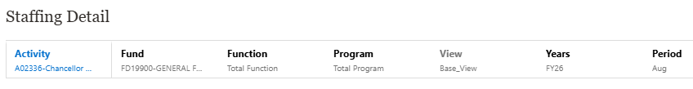
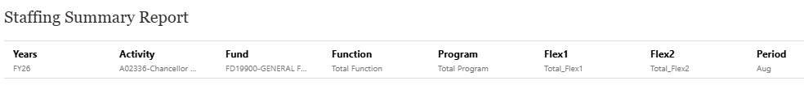
- Staffing Summary Report will indicate which COA’s are in and out of balance.
  - Salary - Out of Balance column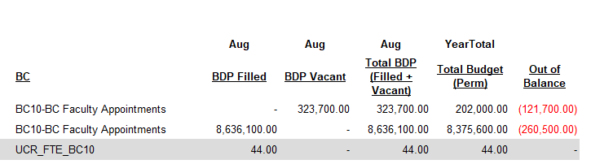

    - Positive balance means that the COA has too much budget and might need to create an open provision.
      - Never move budget out of a staffing BC unless this has been discussed with FP&A first.
      - Never create a negative Perm budget to balance staffing.
    - Negative balance means that the COA doesn’t have enough budget and needs to either have budget added to the COA or a position within BDP needs to be moved to a different fund source.
      - If the negative balance is caused by Ranges, Merits, Promotions, Across the Board (ATB) or Step Increase (STI), then a costing report for core funds will be sent to the ORG for review and funding before the next Staffing due date. Please ensure that the funding on the costing reports is correct.
  - FTE – Out of Balance column
    - Positive balance means that the COA has less FTE than expected. Using the 4.50 FTE Data Entry form in SmartView make the adjustment needed.
      - For an existing COA, select the current month, add the adjustment needed, click on Submit. The reports in Oracle Budget are now updated with the new information.
      - For a COA that does not exist, Right click on column C “UCR_FTE_BCxx” > scroll down to SmartView > click “ADD FTE RECORD” > Select the correct Function, Program and FTE Account from the drop-down menu > Click on “Yes, Add FTE Record” > The new record will populate under the current month > Add the FTE needed and click submit data. The reports in Oracle Budget are now updated with the new information.
      - For more detailed instructions please see FTE in SmartView Training on FP&A website.
    - Negative balance means that the COA has more FTE than expected. Using the 4.50 FTE Data Entry form in SmartView make the adjustment needed (instructions above).
    - BDP adjustment might be needed, especially if an employee left the department or was recently hired. For this adjustment you will need access to BDP and position ID.
      - To add or remove a position within BDP for the staffing reports in Oracle budget click on the STF Flag.
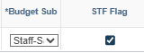
        - Checked the position is included in the Staffing report
        - Un-checked the position is NOT included in the Staffing report
        - Staffing reports are updated by the system and will have a one day delay (processed in BDP on Monday will show on Tuesday reports).
      - For more detailed instructions please see BDP TRAINING on FP&A website.

- Staffing Detail will provide you what COA an employee is paid on with the budgeted position amount and FTE.
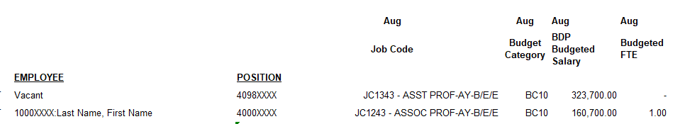

Appendix C: Costing Reports:
- It is considered a Best Practice that the ORG compares the Staffing Detail Report from the last staffing period that was in balance with the current staffing report (June 2025 vs. Sept 2025).
  - Generate the Excel version of the Staffing Summary and Staffing Detail reports in Oracle Budget
    - Reports > Library > 7.00 Reporting and Analytics > 7.10 UCR - Financial Reports
    - Ensure you select the correct POV for the search, specifically the Year and Period (For reports older than FY26 please select June as the period)
      - If the month is not showing and TPx is showing, make the following adjustments. Click on the gear icon > member Labels > Alias
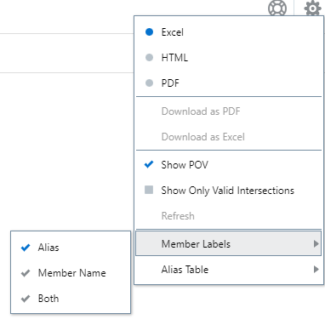
- For the comparison, the best practice is to use the older (in balance) staffing detail report and create new columns to the side to reflect the period being used to compare.
- Then create a column with a formula “June BDP Salary – August BDP Salary”, and do the same thing with FTE.
- Then create a column with how much funding will be received on the costing report to see if the amount matches the difference from the step above.
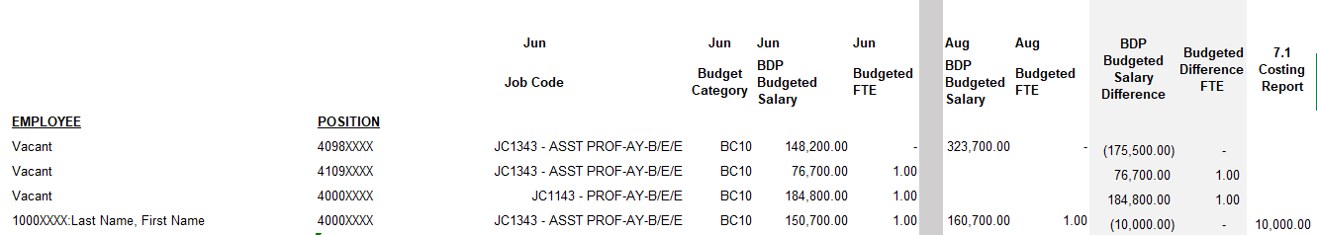
- From the example above you can see that two Vacant positions have been removed in BDP.
- Also, you can see that the employee June BDP and August BDP salary amount was increased by $10k, this amount happens to match the 7.1 costing report.
  - If this amount did not match, the next step is to use BDP Workforce Job Summary to see what changes were made within UCPath for this employee.
    - HR Employee Information > Workforce Job Summary > EID > Search
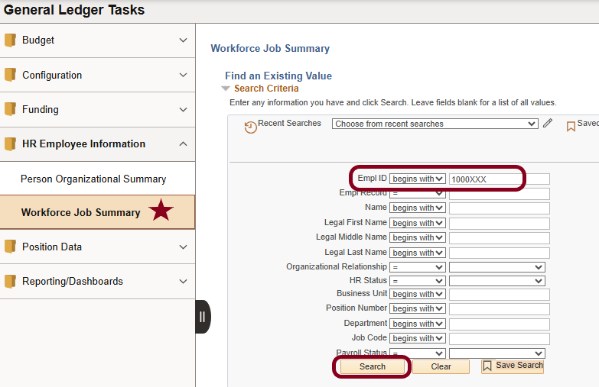
- Select the correct position by clicking on the >
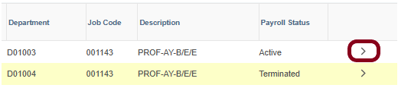
- The job information will be displayed under the General tab
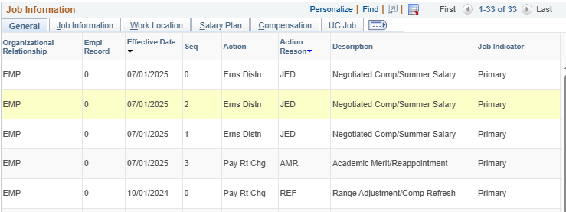
- Go to the Compensation tab and click on the components to see the salary breakdown
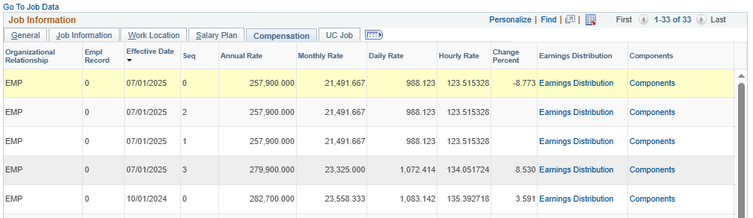
- This will give you the salary breakdown, UNANNL is the annual salary and the UCOFF1 is the off scale.
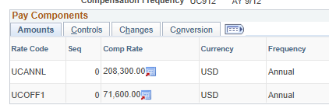
- Ensure these amounts match the costing report for the salary action dates.
- If they don’t match, make the adjustments as needed per the costing report instructions.

